INDEX

Sr. No. | Title | Page No.
Part-I Introduction
1.1 | Introduction to Project | 3
1.2 | Project Profile | 4
Part-II System Analysis and Design
2. | Project Planning | 6
2.1 | Scope of the System | 6
2.2 | Software Process Model | 6
2.3 | Project Team | 8
3. | System Design | 9
3.1 | Data Flow Diagrams | 9-26
3.2 | ER Diagram | 27
3.3 | Database Design | 28-31
Part-III Implementation Details
4. | Screen Layouts | 33-55
Part-IV Tools & Technologies
5 | About PHP | 57
6 | About Bootstrap Framework | 58
7 | About MySQL | 59
8 | Bibliography | 41

Part – I
Introduction

  - Introduction to Project

Project Title: Restaurant Management System
Project Profile
A Restaurant Management System Project focuses on simplifying and computerizing the operations of restaurants. The primary objective of an RMS is to properly organize and manage the menu and orders available in a restaurant, making it easier for management to carry out optimizing orders issue operations and create a user-friendly experience for customers.
Purpose
- Restaurant Management System Project records and maintains orders details so that it is easily accessible.
- It efficiently manages the menu details to ensure easy navigation, quick orders of information, and seamless interaction with the system.
- It manages food ordering effectively as well calculate fine based on time.
- It efficiently manages orders request for user.
- It generates daily reports that help the manager to track the system operations.

Project Users and Functionalities
Admin:
- Login using Username and Password.
- Can view dashboard for quick updates related to orders.
- They can add new items in the menu.
- They can update menu details like their price, images and their availability.
- They can manage the status of customers orders.
Customer:
- View previously issued book details.
- View book details category and subject wise.
- Request to issue a particular book.
- View issued book details i.e., when to collect book, due date and late fee if return date exceeds due date.

  - Project Profile

Project Title | Restaurant Management System
Project Type | Web Application
Font End Technologies | PHP - Bootstrap Framework
Back End Technologies | My-SQL
Duration | 2 Months
Internal Guide | Mr.
Submitted By | Vipul Maurya - 39, Adarsh Singh - 75

Part – II
System Analysis and Design

2. Project Planning

2.1 Scope of the System
- Implementing secure login and role-based access for admin and customer.
- When customer is logged in, he/she can view available menu details and category wise, view previously issued order details, make request to make orders and view status of requested orders.

2.2 Software Process Model

Waterfall Model
Waterfall approach was first SDLC Model to be used widely in Software Engineering to ensure success of the project. In "The Waterfall" approach, the whole process of software development is divided into separate phases. In this Waterfall model, typically, the outcome of one phase acts as the input for the next phase sequentially.

The different phases of the Waterfall Model.
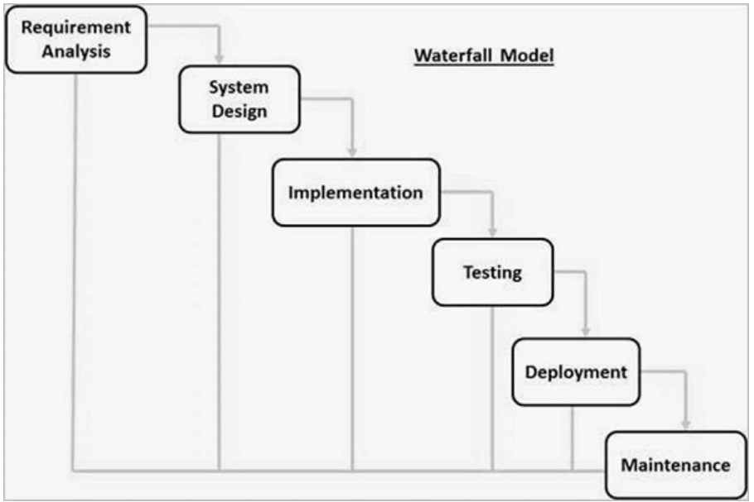

The sequential phases in Waterfall model are
Requirement Gathering and Analysis
Collect requirements for Admin and Customer, such as login, menu management, ordering, billing, and reports.

System Design
Design the website structure, Admin and Customer pages, database, and system workflow.
Implementation
Develop the RMS using PHP, Bootstrap, HTML, CSS, JavaScript, and MySQL.
Integration and Testing
Integrate all modules and test login, menu, cart, orders, billing, and reports.
Deployment of system
Deploy the completed system on the required server for Admin and Customer use.
Maintenance
Fix errors, improve features, and update the system when required.

2.3 Project Team
Personal Profile
Name | Vipul Maurya
Address | Guru Krupa Residency, Kamli faliya, Silvassa, DNH
Contact No. | 8128922158
E-mail Address | maurya.vipul2006@gmail.com
Roll No. | 39

Personal Profile
Name | Adarsh Singh
Address | Masat, Silvassa, DNH
Contact No. | 9157465386
E-mail Address | ad3768212@gmail.com
Roll No. | 75

3.1 Data Flow Diagram

0-LEVEL DFD

ADMIN
Customer
0.0
Restaurant Management System
login
access
login
access

1-LEVEL DFD

ADMIN
Customers
1.0
Login
Id & Password
2.0
Manage Menu
3.0
Transactional Entry
Entry
Process
4.0
Manage Orders
5.0
Manage Tables
6.0
View Reports
Database
Id & Password
Check Login Credentials
Master Entry Info
Master Entry Info
Transactional Entry Info
Transactional Entry Info
Order Status Info
Orders Info
Manage Tables Info
Table Info
View Info
Database Info

LEVEL-2 DFD for Process 2.0
(Master Entry Process)
ADMIN
2.5
Manage
Publisher
2.6
Manage
User Type
2.7
Manage
General Details
2.3
Manage
Category
2.1
Manage
Department
2.4
Manage
Author
2.2
Manage
Subject
Department Details
Subject Details
Category Details
Author Details
User Type Details
General Details
Publisher Details
Add Department Info
Add Department Info
Department Details
Department Details
Add Subject Info
Add Subject Info
Subject Details
Subject Details
Add Category Info
Add Category Info
Category Details
Category Details
Add Author Info
Add Author Info
Author Details
Author Details
Add Publisher Info
Add Publisher Info
Publisher Details
Publisher Details
Add User Type Info
Add User Type Info
User Type Details
User Type Details
Add General Info
Add General Info
General Details
General Details
LEVEL-2 DFD for Process 3.0
(Transactional Entry Process)

ADMIN
3.1
Manage Supplier
Supplier Details
Bill Details
Book Details
User Details
Book Copy Details
Add Supplier Info
Supplier Details
Add Bill Info
Bill Details
Add Book Info
Book Details
Add Book Copy Info
Book Copy Details
Add User Info
User Details
3.2
Manage Bill
3.3
Manage Book
3.4
Manage Book Copy
3.4
Manage User
Add Supplier Info
Supplier Details
Add Bill Info
Bill Details
Add Book Info
Book Details
Add Book Copy Info
Book Copy Details
Add User Info
User Details

LEVEL-2 DFD for Process 4.0
(MANAGE BOOK ISSUE)

ADMIN
4.1
Book Request
4.2
Check Maximum Issued Book

4.3
Book Issue
Book Request Details
Generate a Book Issue Request
STUDENT
General Details
Book Issue Details
Book Copy Details
Book Request Details
View Book Request Info
View Student Info
Check Student Info
Reject Request to Issue Book
Accept Request to Issue Book
View Info to Collect Book

LEVEL-2 DFD for Process 5.0
(MANAGE BOOK RETURN)

ADMIN
5.1
Check Book Issue Details
5.2
Calculate Fine

5.3
Book Return
Book Issue Details
Return Book
STUDENT
General Details
Book Issue Details
Book Copy Details
User Details
View Book Issue Info
View Fine If Any
Book Issue Id
Return Book

LEVEL-3 DFD for Process 2.1
(MANAGE DEPARTMENT)

ADMIN
2.1.1
Insert Department
2.1.2
Update
Department
2.1.3
Delete
Department
Department Details
Add Department Info
Department Details
Add Department Info
Department Details
Department Details
Department Details
Department Details
Department Details
Update Department Info
Delete Department Info
Update Department Info
Delete Department Info

LEVEL-3 DFD for Process 2.2
(MANAGE SUBJECT)

ADMIN
2.2.1
Insert Subject
2.2.2
Update Subject
2.2.3
Delete Subject
Subject Details
Add Subject Info
Subject Details
Add Subject Info
Subject Details
Subject Details
Subject Details
Subject Details
Subject Details
Update Subject Info
Delete Subject Info
Update Subject Info
Delete Subject Info

LEVEL-3 DFD for Process 2.3
(MANAGE CATEGORY)

ADMIN
2.3.1
Insert Category
2.3.2
Update Category
2.3.3
Delete Category
Category Details
Add Category Info
Category Details
Add Category Info
Category Details
Category Details
Category Details
Category Details
Category Details
Update Category Info
Delete Category Info
Update Category Info
Delete Category Info

LEVEL-3 DFD for Process 2.4
(MANAGE AUTHOR)

ADMIN
2.4.1
Insert Author
2.4.2
Update Author
2.4.3
Delete Author
Author Details
Add Author Info
Author Details
Add Author Info
Author Details
Author Details
Author Details
Author Details
Author Details
Update Author Info
Delete Author Info
Update Author Info
Delete Author Info

LEVEL-3 DFD for Process 2.5
(MANAGE PUBLISHER)

ADMIN
2.5.1
Insert Publisher
2.5.2
Update
Publisher
2.5.3
Delete
Publisher
Publisher Details
Add Publisher Info
Publisher Details
Add Publisher Info
Publisher Details
Publisher Details
Publisher Details
Publisher Details
Publisher Details
Update Publisher Info
Delete Publisher Info
Update Publisher Info
Delete Publisher Info

LEVEL-3 DFD for Process 2.6
(MANAGE USER TYPE)

ADMIN
2.6.1
Insert User Type
2.6.2
Update User Type

2.6.3
Delete User Type

User Type Details
Add User Type Info
User Type Details
Add User Type Info
User Type Details
User Type Details
User Type Details
User Type Details
User Type Details
Update User Type Info
Delete User Type Info
Update User Type Info
Delete User Type Info

LEVEL-3 DFD for Process 2.7
(MANAGE GENERAL DETAILS)

ADMIN
2.7.1
Insert General Details
2.7.2
Update General Details

2.7.3
Delete General Details

General Details
Add General Details Info
General Details
Add General Details Info
General Details
General Details
General Details
General Details
General Details
Update General Details Info
Delete General Details Info
Update General Details Info
Delete General Details Info

LEVEL-3 DFD for Process 3.1
(MANAGE SUPPLIER)

ADMIN
3.1.1
Insert Supplier
3.1.2
Update Supplier

3.1.3
Delete Supplier

Supplier Details
Add Supplier Info
Supplier Details
Add Supplier Info
Supplier Details
Supplier Details
Supplier Details
Supplier Details
Supplier Details
Update Supplier Info
Delete Supplier Info
Update Supplier Info
Delete Supplier Info

LEVEL-3 DFD for Process 3.2
(MANAGE BILL)

ADMIN
3.2.1
Insert Bill
3.2.2
Update Bill

3.2.3
Delete Bill
Bill Details
Add Bill Info
Bill Details
Add Bill Info
Bill Details
Bill Details
Bill Details
Bill Details
Bill Details
Update Bill Info
Delete Bill Info
Update Bill Info
Delete Bill Info

LEVEL-3 DFD for Process 3.3
(MANAGE BOOK)

ADMIN
3.3.1
Insert Book
3.3.2
Update Book

3.3.3
Delete Book
Book Details
Add Book Info
Book Details
Add Book Info
Book Details
Book Details
Book Details
Book Details
Book Details
Update Book Info
Delete Book Info
Update Book Info
Delete Book Info

LEVEL-3 DFD for Process 3.4
(MANAGE BOOK COPY)

ADMIN
3.4.1
Insert Book Copy
3.4.2
Update Book Copy

3.4.3
Delete Book Copy
Book Copy Details
Add Book Copy Info
Book Copy Details
Add Book Copy Info
Book Copy Details
Book Copy Details
Book Copy Details
Book Copy Details
Book Copy Details
Update Book Copy Info
Delete Book Copy Info
Update Book Copy Info
Delete Book Copy Info

LEVEL-3 DFD for Process 3.5
(MANAGE USER)

ADMIN
3.5.1
Insert Student
3.5.2
Update Student

3.5.3
Delete Student
User Details
Add Student Info
Student Details
Add Student Info
Student Details
Student Details
Student Details
Student Details
Student Details
Update Student Info
Delete Student Info
Update Student Info
Delete Student Info

3.2 Er Diagram

Admin / Librarian
Student
Add
u_fname
u_lname
u_email
u_password
u_id
u_fname
u_lname
u_enrollment
u_password
u_id
u_email
Manage
Book
b_id
b_title
b_isbn
b_edition
b_price
Writes
Author
Publisher
Publishes
a_id
a_name
pub_id
pub_name
Has
Book Copy
bk_id
bk_accession_no
bk_available
bk_location
Requests
r_id
r_status
date_of_request
Issue / Return
bi_id
date_of _issue
date_of _return
due_date
late_fee
is_return

3.3 Database Design

USERS DETAILS:
Name | Type | Length | Constraint | Null | Description
id | int | - | PRIMARY KEY | - | Auto increment
username | varchar | 50 | UNIQUE | - | Username of user
email | varchar | 100 | UNIQUE | - | Email address
password | varchar | 255 | - | - | Encrypted password
role | enum | - | - | - | Type of user
full_name | varchar | 100 | - | YES | Full name of user
phone | varchar | 20 | - | YES | Contact number
created_at | timestamp | - | - | - | Account creation date

MENU ITEMS DETAILS:
Name | Type | Length | Constraint | Null | Description
id | int | - | PRIMARY KEY | - | Auto increment
name | varchar | 100 | - | - | Name of food item
description | text | - | - | YES | Description of food
price | decimal | 10,2 | - | - | Price of food item
category | varchar | 50 | - | - | Food category
image | varchar | 255 | - | YES | Food image filename
is_available | boolean | - | - | YES | Availability of food
created_at | timestamp | - | - | - | Item creation date

ORDERS DETAILS:
Name | Type | Length | Constraint | Null | Description
id | int | - | PRIMARY KEY | - | Auto increment
user_id | int | - | FOREIGN KEY | YES | Customer user ID
total_amount | decimal | 10,2 | - | - | Total order amount
status | enum | - | - | YES | Current order status
order_type | enum | - | - | - | Type of order
table_number | int | - | - | YES | Restaurant table number
created_at | timestamp | - | - | - | Order creation date

ORDER ITEMS DETAILS:
Name | Type | Length | Constraint | Null | Description
id | int | - | PRIMARY KEY | - | Auto increment
order_id | int | - | FOREIGN KEY | - | Order ID
menu_item_id | int | - | FOREIGN KEY | - | Menu item ID
quantity | int | - | - | - | Quantity ordered
price | decimal | 10,2 | - | - | Price of item

RESERVATION DETAILS:
Name | Type | Length | Constraint | Null | Description
id | int | - | PRIMARY KEY | - | Auto increment
user_id | int | - | FOREIGN KEY | YES | Customer user ID
name | varchar | 100 | - | - | Customer name
phone | varchar | 20 | - | - | Contact number
email | varchar | 100 | - | YES | Customer email
date | date | - | - | - | Reservation date
time | time | - | - | - | Reservation time
number_of_guests | int | - | - | - | Number of guests
table_number | int | - | - | YES | Reserved table number
status | enum | - | - | YES | Reservation status
created_at | timestamp | - | - | - | Reservation creation date

TABLES DETAILS:
Name | Type | Length | Constraint | Null | Description
id | int | - | PRIMARY KEY | - | Auto increment
table_number | int | - | UNIQUE | - | Restaurant table number
capacity | int | - | - | - | Maximum seating capacity
status | enum | - | - | YES | Current table status
location | varchar | 50 | - | YES | Table location

Part – III
Implementation Details

ADMIN PORTAL
Admin-Login Page

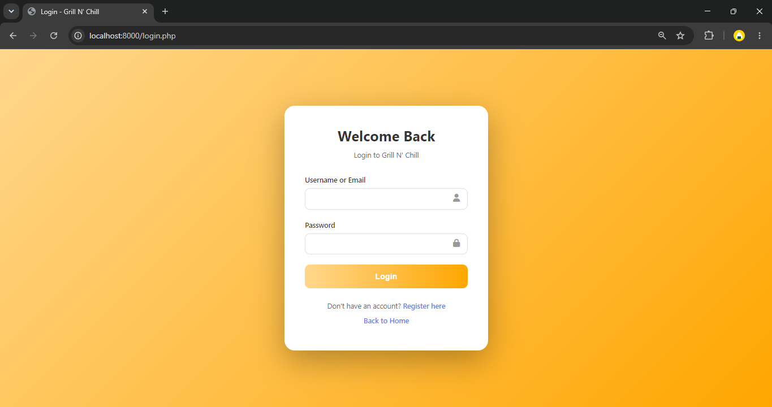

Admin Registration Page

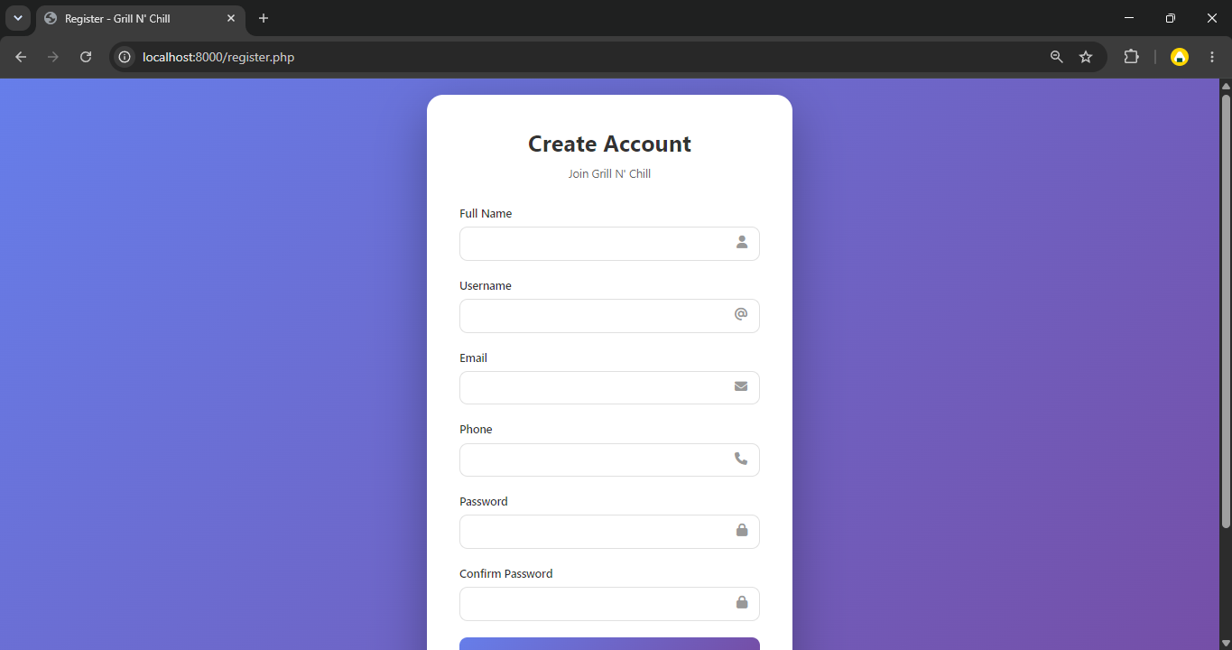

Admin Dash Board

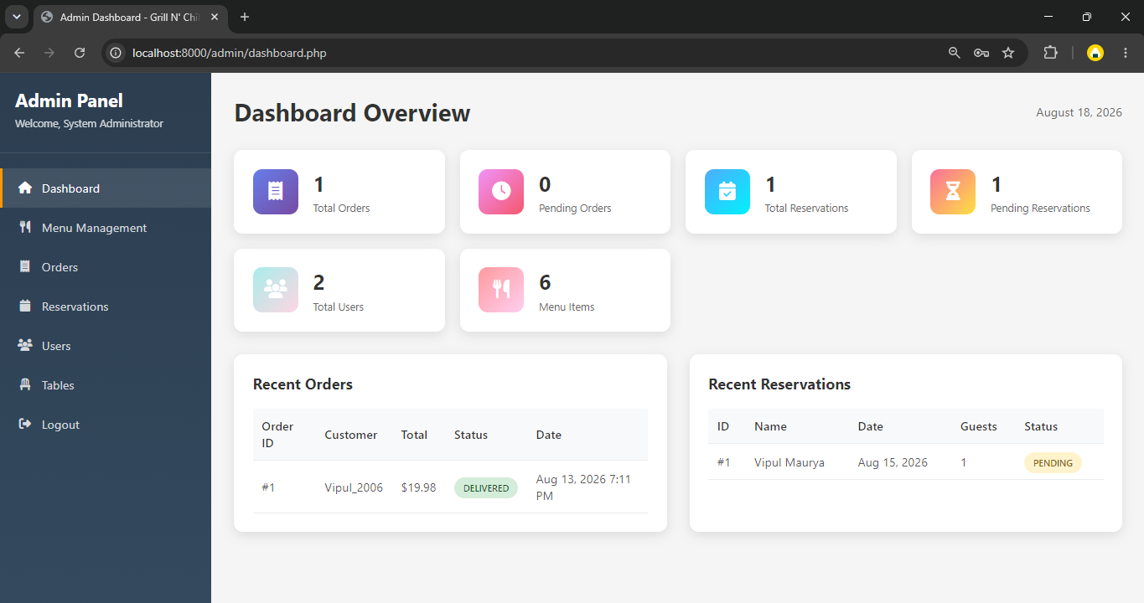

Page to Menu Management
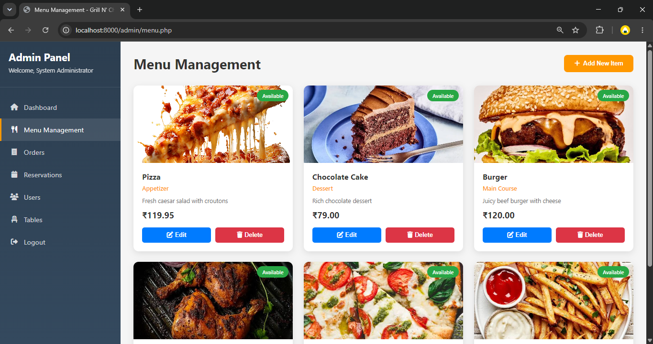

Modal to add New menu item
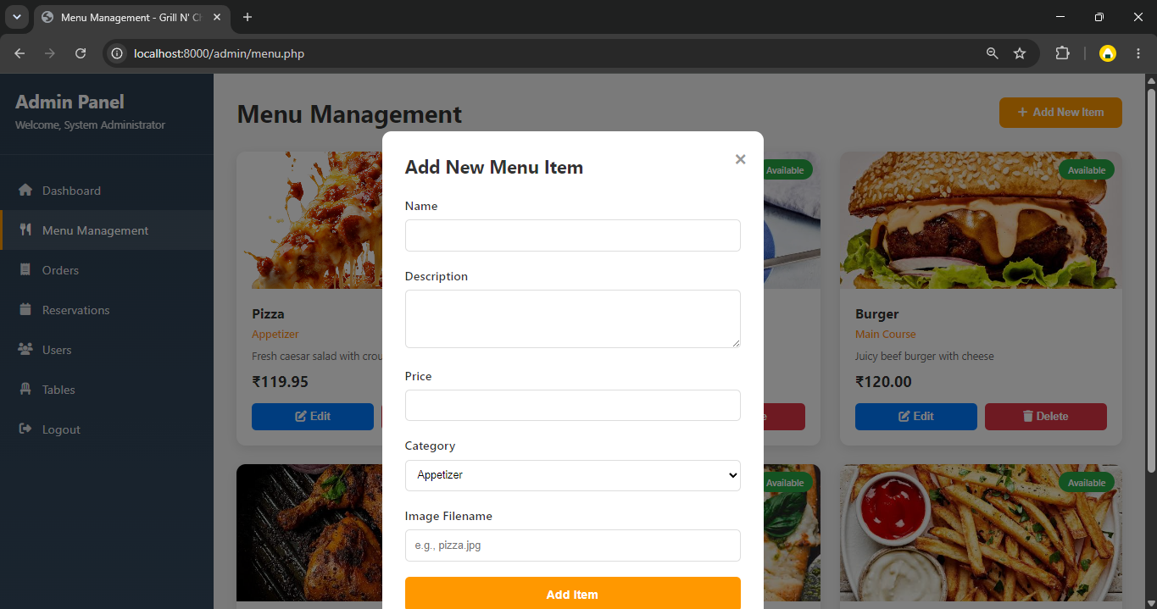

Page to Order Management

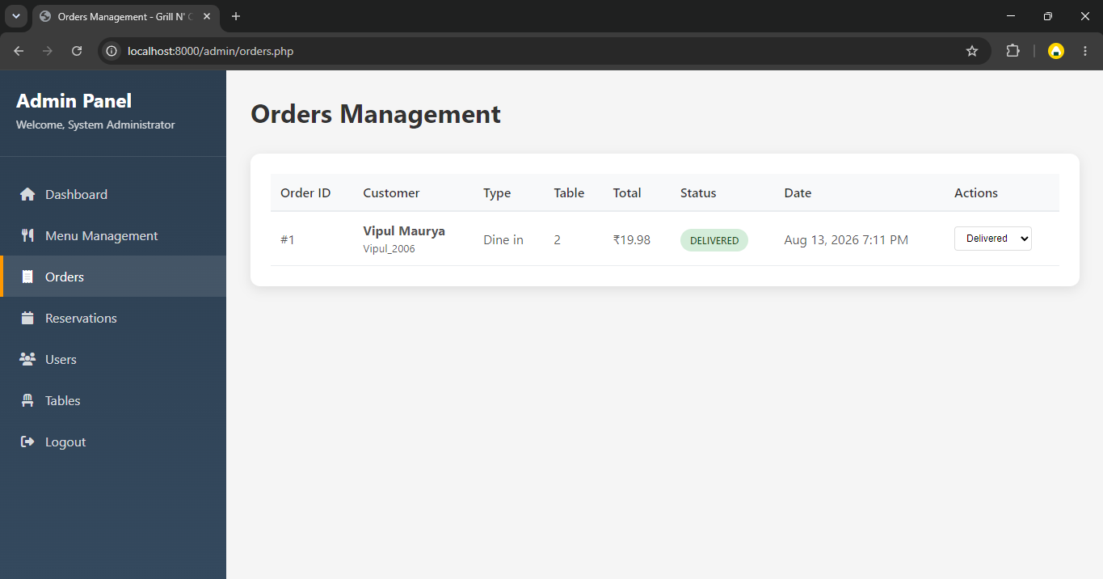

Page to Reserve table Management

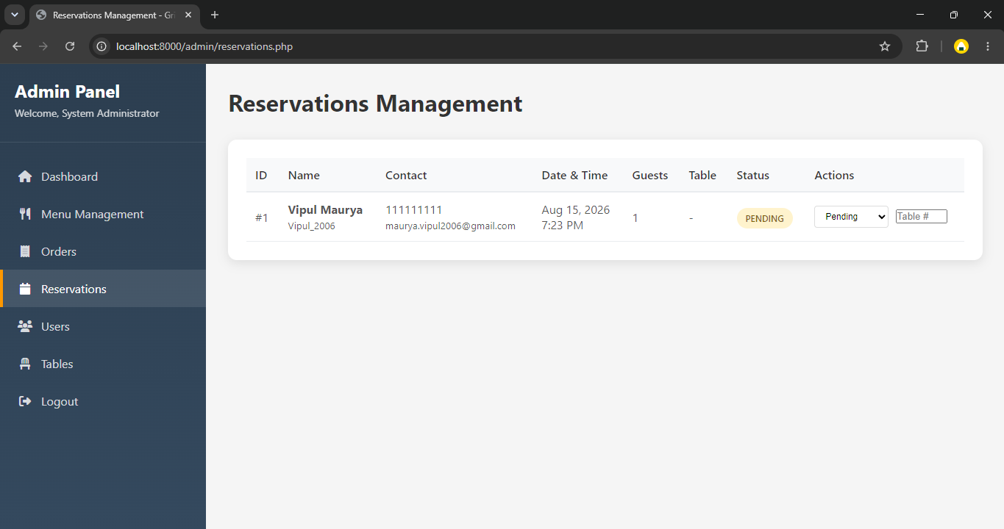

Page to User Details

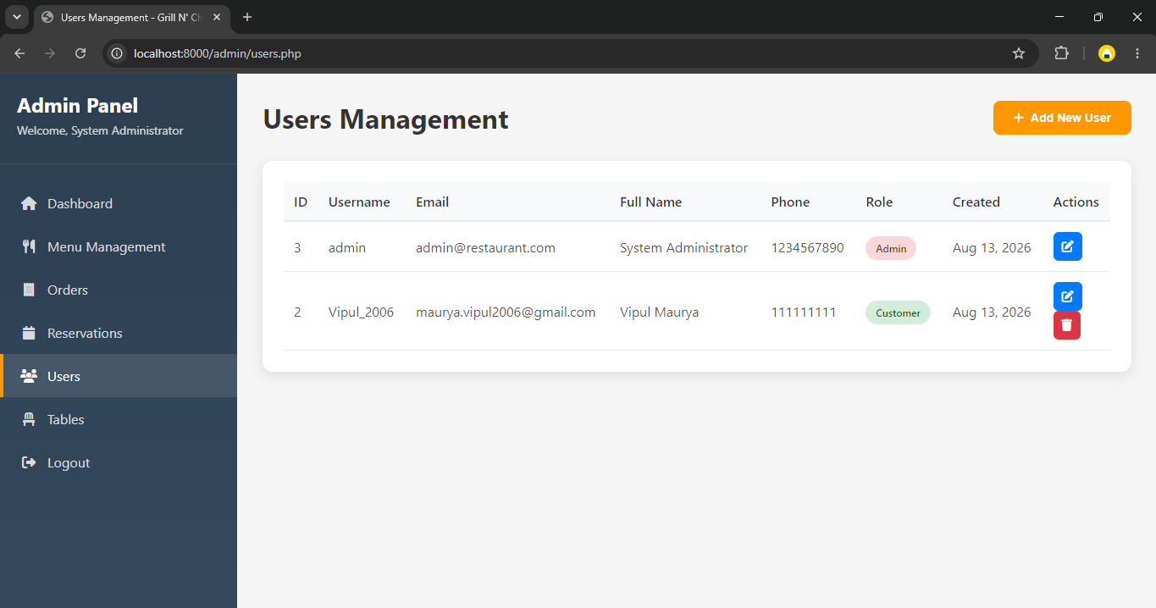

Page to Home Page

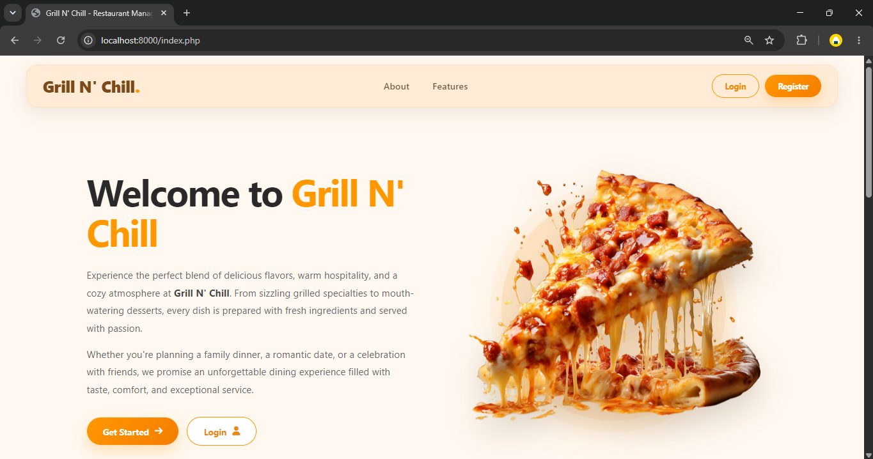

Menu Page

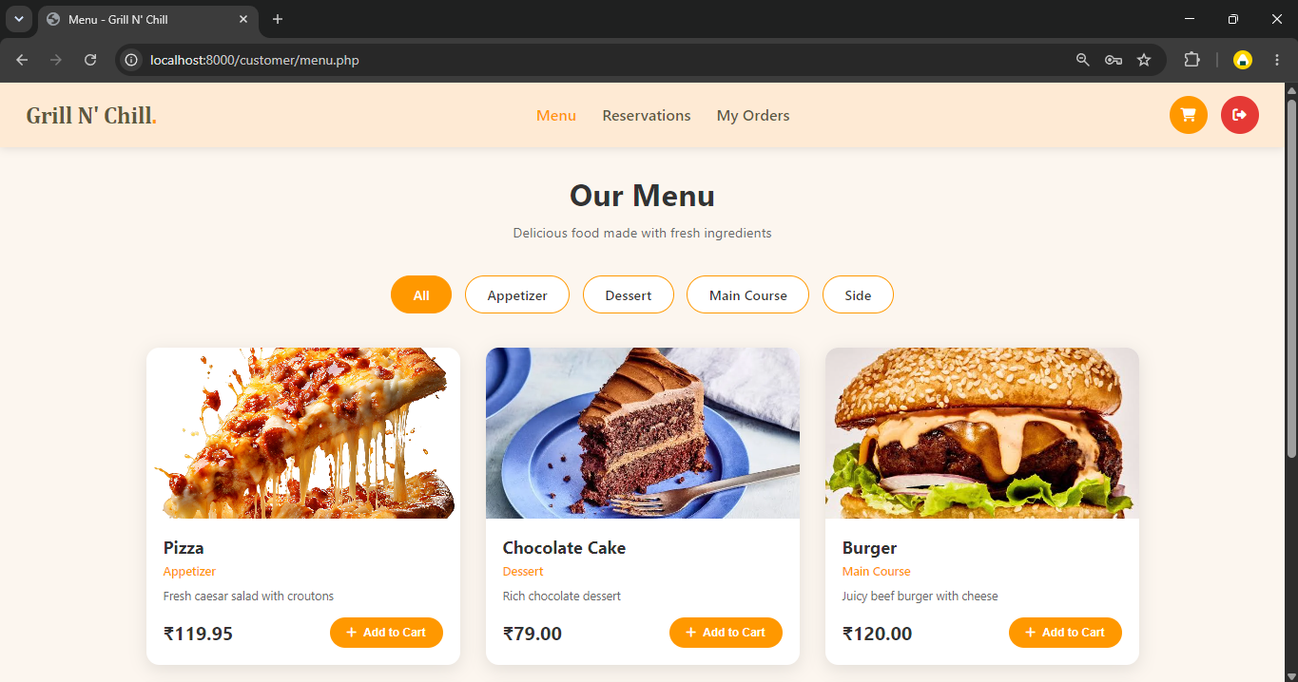

Table Reserve Page

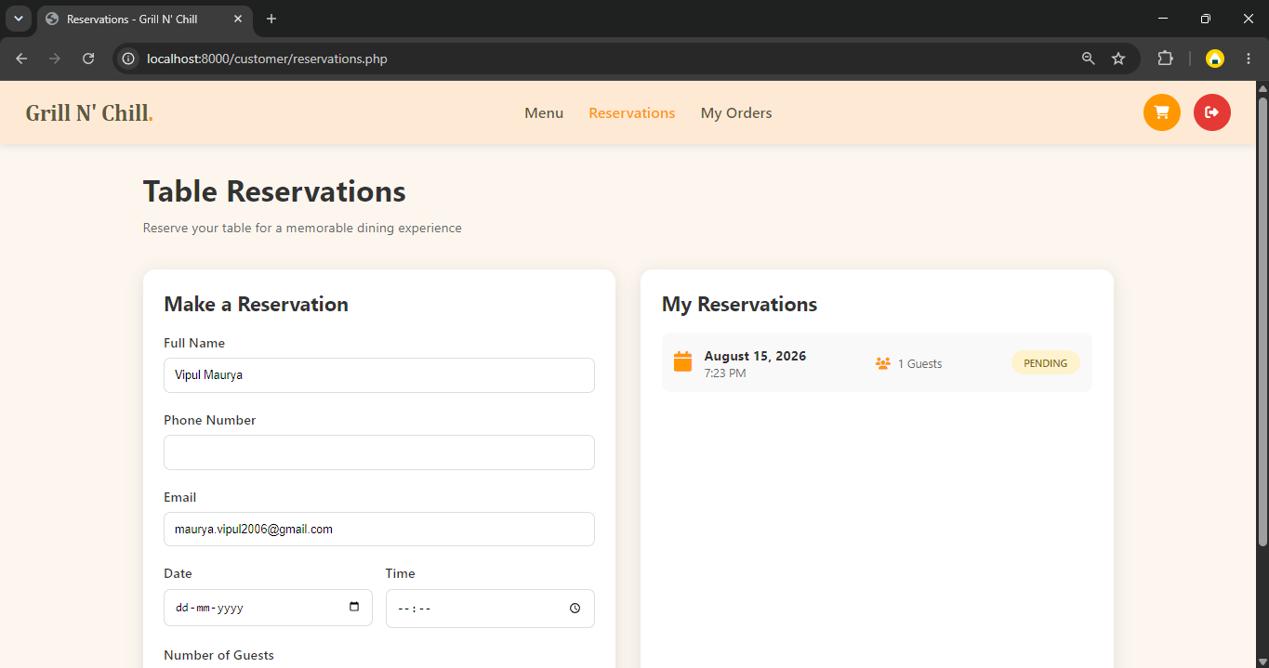

Order History and Status Page

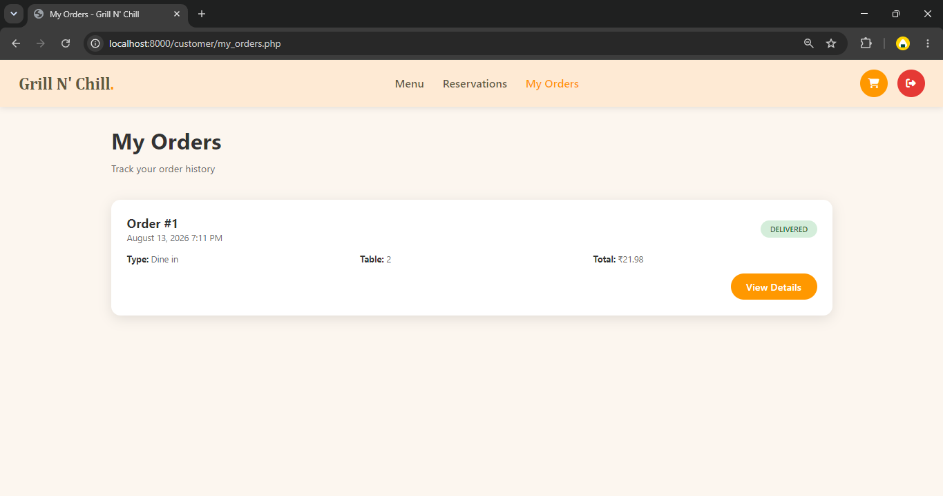

Cart Page

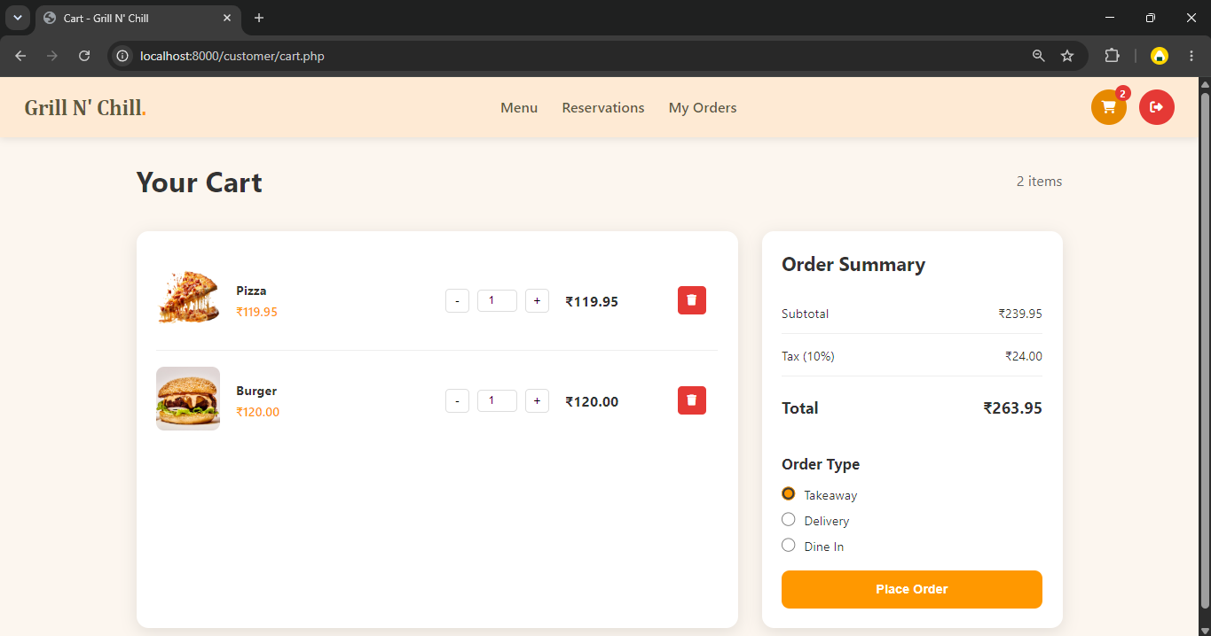

Part-IV
Tools & Technologies

5. About PHP

Introduction to PHP
PHP (Hypertext Preprocessor) is a widely-used open-source scripting language designed primarily for web development. It is embedded within HTML and executed on the server, making it a powerful tool for creating dynamic and interactive web applications. Initially created by Rasmus Lerdorf in 1994, PHP has evolved into a robust and flexible language that powers millions of websites worldwide, including major platforms like Facebook, WordPress, and Wikipedia.

Features of PHP
PHP offers numerous features that make it a preferred choice for developers:

Open Source and Free – PHP is freely available for anyone to use and modify. This makes it accessible to beginners and professionals alike.

Cross-Platform Compatibility – It runs on various operating systems, including Windows, Linux, macOS, and Unix, ensuring flexibility in deployment.

Easy to Learn and Use – PHP has a simple syntax similar to C and JavaScript, making it easy to grasp for developers familiar with these languages.

Server-Side Execution – PHP scripts are executed on the server, and only the resulting HTML is sent to the client's browser, enhancing security and efficiency.

Database Connectivity – PHP seamlessly integrates with multiple databases, such as MySQL, PostgreSQL, and MongoDB, allowing dynamic content management.

Support for Various Protocols – PHP supports protocols like HTTP, HTTPS, FTP, and more, making it suitable for web services and APIs.

Extensive Library Support – It provides numerous built-in functions and extensions for handling images, encryption, file handling, and more.

Applications of PHP
PHP is versatile and used in various web applications, including:

Dynamic Websites – It enables interactive features like user authentication, comments, and content updates.

Content Management Systems (CMS) – Platforms like WordPress, Joomla, and Drupal rely on PHP for managing website content.

E-commerce Websites – Online stores such as Magento, WooCommerce, and OpenCart use PHP to handle product catalogs, payments, and orders.

Web Applications – Custom applications like CRM, ERP, and project management tools are often built using PHP.

APIs and Web Services – PHP facilitates API development, allowing applications to communicate seamlessly.
6. About Bootstrap Framework

Introduction to Bootstrap
Bootstrap is a free, open-source front-end framework designed to help developers create responsive and mobile-first websites quickly and efficiently. Developed by Twitter and released in 2011, Bootstrap provides a collection of HTML, CSS, and JavaScript components that streamline the web development process. It is one of the most popular front-end frameworks, widely used for building modern, responsive, and visually appealing websites.

Key Features of Bootstrap
Bootstrap offers several powerful features that make it a preferred choice for web developers:

Responsive Design – Bootstrap’s grid system automatically adjusts the layout to fit different screen sizes, making websites mobile-friendly.

Pre-built Components – It includes ready-to-use UI components like buttons, navigation bars, modals, alerts, and carousels, reducing development time.

Customizable – Developers can modify Bootstrap’s default styles and settings using CSS or by overriding the built-in variables in Sass.

Cross-Browser Compatibility – Bootstrap ensures consistency across different web browsers like Chrome, Firefox, Safari, and Edge.

Grid System – Its flexible 12-column grid layout helps design responsive and well-structured web pages.

Extensive Documentation – Bootstrap provides clear and detailed documentation, making it easy for beginners to get started.

JavaScript Plugins – It includes built-in JavaScript components like dropdowns, modals, tooltips, and popovers without needing additional libraries.

Applications of Bootstrap
Bootstrap is widely used for various web development projects, including:

Corporate Websites – Many businesses use Bootstrap for sleek and professional website designs.

Landing Pages – It is perfect for building responsive and attractive landing pages.

Admin Dashboards – Bootstrap-based dashboards provide clean and functional user interfaces.

E-commerce Websites – Online stores utilize Bootstrap for enhanced usability and responsiveness.

Web Applications – Many modern web apps use Bootstrap to speed up UI development.

7. About MySQL

Introduction to MySQL
MySQL is an open-source relational database management system (RDBMS) that is widely used for storing, managing, and retrieving structured data. It was initially developed by MySQL AB in 1995 and later acquired by Oracle Corporation. MySQL is known for its speed, reliability, and ease of use, making it a preferred choice for web applications, enterprise software, and cloud-based solutions.

Key Features of MySQL
Open-Source and Free – MySQL is freely available under the GNU General Public License (GPL), although commercial versions are also available.

Relational Database Management – It organizes data into tables with rows and columns, enabling efficient storage and retrieval.

High Performance – MySQL is optimized for handling large amounts of data with minimal latency, making it ideal for high-traffic websites.

Scalability – It supports scaling both vertically (adding resources to a single server) and horizontally (distributing the database across multiple servers).

Data Security – MySQL offers robust security features such as user authentication, encryption, and access control.

Cross-Platform Compatibility – It runs on multiple operating systems, including Windows, Linux, macOS, and Unix.

Integration with Web Technologies – MySQL seamlessly integrates with web development technologies like PHP, Python, Java, and Node.js.

Support for Transactions – It supports ACID (Atomicity, Consistency, Isolation, Durability) transactions, ensuring data integrity.

Replication and Clustering – MySQL provides replication and clustering for load balancing and high availability.

8. Bibliography

Search Engine : Google

Online Resources:
- www.GeeksforGeeks.org
- www.tutorialspoints.com
- www.w3school.com

9. Conclusion
In conclusion, the Restaurant Management System provides an effective solution for improving restaurant operations and customer service. In the future, the system can be enhanced by adding online payment facilities, table reservations, order notifications, inventory management, and sales analytics to make it more comprehensive and efficient.

